South Fork Boise Watershed Collaborative
Quarterly Meeting Agenda
Thursday February 22, 2024 from 1:00pm to 4:00pm
Reclamation Snake River Area Office
Learning from others- The Green River below Fontenelle Dam in Wyoming has experienced a similar reduction in side channel connectivity to the SF Boise below Anderson Ranch Dam. TU and USFWS have started to excavate side channels with a goal of maintaining connectivity at winter minimum flows. Learning about their process could inform the potential side channel work on the SF Boise.
- Green River Side Channel work (USFWS and TU). TU contracted OneFish Engineering to model and map potential locations for adding/deepening side channels on the Green River. Each potential location was summarized with how much material would need to be removed and how much time that was expected to take an excavator crew. The report showed a longitudinal profile (example below) showing where and how deep a new channel would need to be dug to connect at different flow levels.
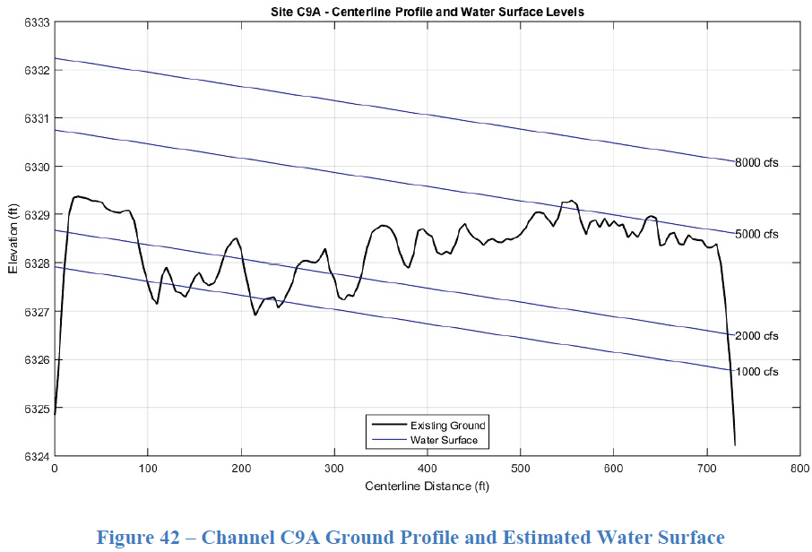
- USFWS used this report to send out their own maintenance crew to do the work as time allows. US Army Corps of Engineers 404 permitting was simplified with the info in the OneFish report. ESA consultation was internal and not representative of our work.
- USFWS and TU believe enough information exists in the positive influence of side channels that monitoring “success” is not occurring. Incidental sighting of fish in newly created channels has occurred.
- Red LiDAR flown in 2018 on the SF Boise could be used to create a similar model/report. Exact dates have been hard to find, but it was flown while flows were between 1600 and 4000 cfs from Anderson Ranch Dam. Additional data collection (ground surveys or green LiDAR) would be needed to model connectivity at lower flows down to the 300 cfs minimum.
Committee Updates (see notes from committee meetings on website)
- Recreation
- Habitat
- Roads and Trails
- Irrigation and Agriculture
- User Survey
- Signage, Outreach and Education
Wild and Scenic Eligibility Designation and its influence on potential projects (IRU)
- The current designation as eligible requires USFS to treat the river as if it were designated. This would be worked out in the NEPA process. The designation divides the river into three reaches with different classifications. Recreational, wild and scenic designations each have outstandingly remarkable values (ORV) that are to be maintained by the land management agency. The designations and ORVs would be more limiting to projects in the lower canyon stretch than the upper roadside stretch.
- Section 1 (13.13 Mi), From Anderson Ranch Dam to Mennecke Creek (Recreational: ORV – Recreation, Geologic, Heritage)
- Section 2 (3.13 Mi), From Mennecke Creek to Trail Creek (Scenic: ORV – Recreation, Geology)
- Section 3 (12.27 Mi), From Trail Creek to Crank Creek (Wild: ORV – Scenic, Recreation, Geology)
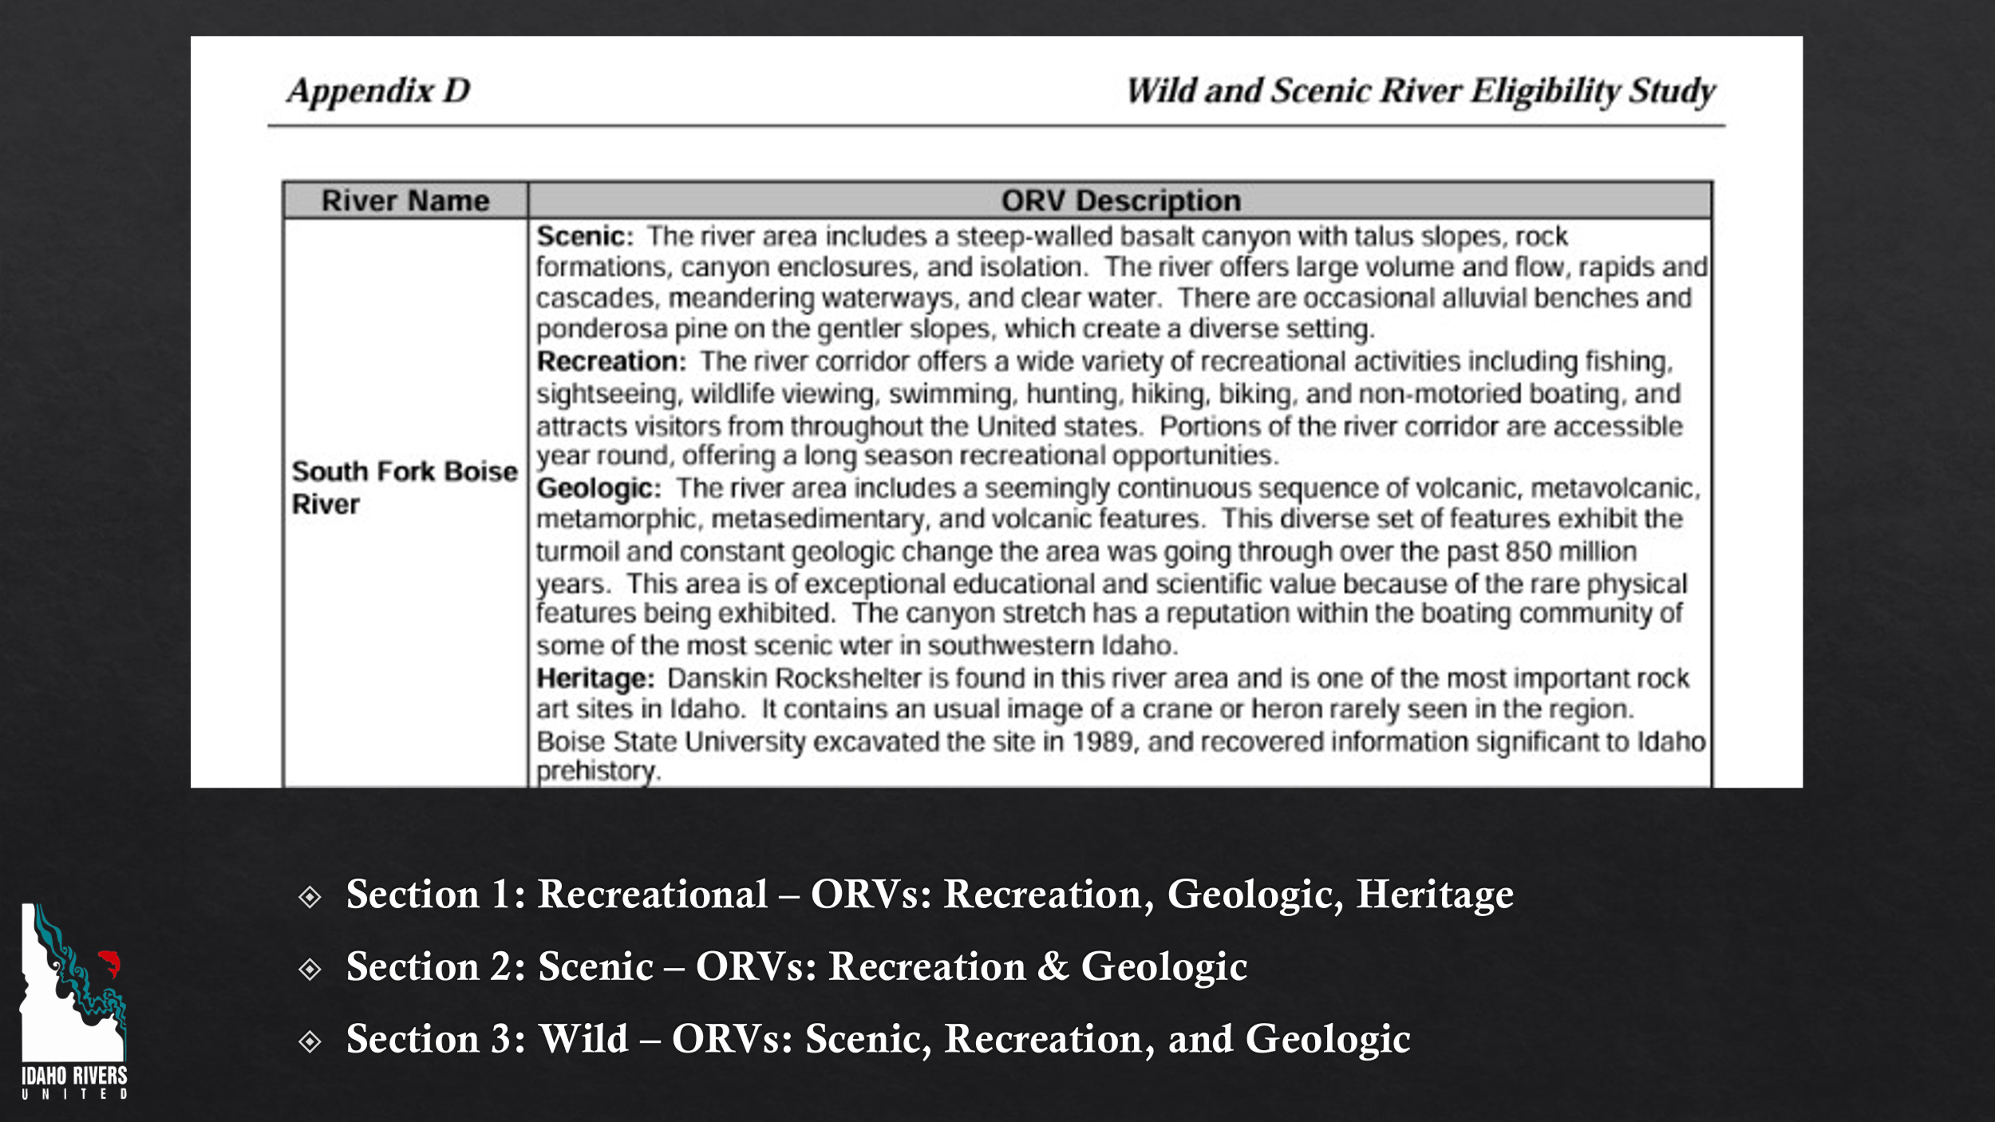
Beaver Dam Analogs- BDAs have the potential to address issues covered by multiple committees. Some have already been installed in the upper Willow Creek drainage on the south side of our watershed. Equipment to install and structure details will change with site specific conditions. A lot of research has already been done on the influence of BDAs and beaver on water temperature, reduced flood flows, increased base flows, fish migration, fish growth, fish survival. The below videos and model are a great place to start to get everyone on the same page with the benefits of BDAs and the opportunity in our watershed.
- Bridge Creek Presentation up to 12:20 https://www.youtube.com/watch?v=eenaS6lo578
  - Steelhead migration not impeded by multiple BDAs or beaver dams
  - Water temperature extremes reduced and temperature heterogeneity increased by increased interaction with ground water
  - Steelhead growth and survival increased
- Short video segments below are worth a watch. We did not have time in the meeting
- Triple Creek Sediment accumulation https://www.youtube.com/watch?v=1KmJnFWQiEY
- Short summary of Birch Creek and Fire stuff start at 16:35 https://www.youtube.com/watch?v=DjgNsrp85vs
- Bringing it back to the South Fork Boise Watershed- Beaver are currently present in sections of the mainstem SF Boise.
- BRAT Beaver Restoration Assessment Tool map has been added to the StoryMap https://arcg.is/1SCva82 Shows best areas in the watershed for BDAs/Beaver.

Draft Mission Statement(s)- working to develop a mission statement for the larger group with the committees working off that one.
The South Fork Boise River Watershed Group’s Mission Is To Provide A Collaborative Opportunity For The Community Who Live, Recreate, Work, Or Are Connected To The South Fork Boise River Watershed To:
- Educate and inspire residents and visitors to appreciate, and protect the watershed by building a shared understanding of current conditions and benefits of the watershed.
- With a focus on water quality and water quantity, identify and pursue actions that protect and conserve the watershed by rehabilitating ecological integrity while maintaining or improving beneficial and recreational uses into the future.

